lab 5

#classification using logistic regression

import numpy as np

import pandas as pd

import matplotlib.pyplot as plt

import seaborn as sns

from sklearn.datasets import load_iris

from sklearn.model_selection import train_test_split

from sklearn.linear_model import LogisticRegression

from sklearn.metrics import confusion_matrix,accuracy_score,classification_report

from sklearn.preprocessing import StandardScaler #for standarization

#load dataset

dataset=load_iris()

x = dataset.data

y = dataset.target

# standarzation dataset

sc = StandardScaler()

x = sc.fit_transform(x)

# train test split

x_train,x_test,y_train,y_test = train_test_split(x,y,test_size=0.2,random_state=0)

#create logistic model

model = LogisticRegression(max_iter=1000)

model.fit(x_train,y_train)

# predict the value

y_pred = model.predict(x_test)

# evaluation metrics

print("confusion_matrix: ",confusion_matrix(y_test,y_pred))

print("accuracy_score : ",accuracy_score(y_test,y_pred)*100) # ACCURACY OUT OF 100 %

print("classification_report : ",classification_report(y_test,y_pred))

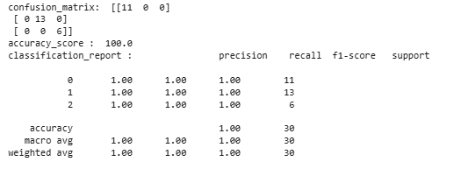

# Visualize OF confusion MATRIX

sns.heatmap(confusion_matrix(y_test,y_pred),annot=True,fmt='d',xticklabels=dataset.target_names,yticklabels=dataset.target_names )

plt.title("Confusion Matrix")

plt.xlabel("Predicted")

plt.ylabel("Actual")

plt.show()

